**git - -version**: To check version of git

**git config - -global user.name ” your name ”** : Set name

**git config - -global user.email “your mail address”** : Set email

**git config - -global - -edit :** directly change in vim editor(name and email)

* :wq (save details and exit vim editor)
* :qa! (undone changes)

**git init** : Initialized empty Git repository

**git status :**  give details about untracked files in directory

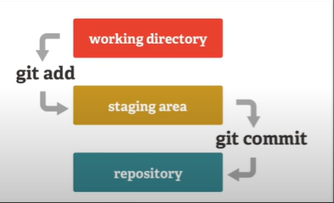**git add . |or| git add <file name>** : add untracked file into stage area

**git commit -m “message”** : commit all files with specified message

**git log** : show how many times you commit changes to a project

**git checkout <commit hash code /branch name>** : go to a specific code or branch

**git branch :** show branches in your repositories

**git branch <branch name>** : to make new branch in your repo

**git checkout -b <branch name> :** to make new branch and also checkout it

**git merge <branch name>** : merge 2 branches

**touch <file name>** : make a specific file in directory , examples: **touch .gitignore** (make gitignore file )

.gitignore : gitignore file is useful: it tells Git exactly which files to ignore and never track

Push an existing repository from the command line:

* git remote add origin <your github url>
* git branch -M master
* 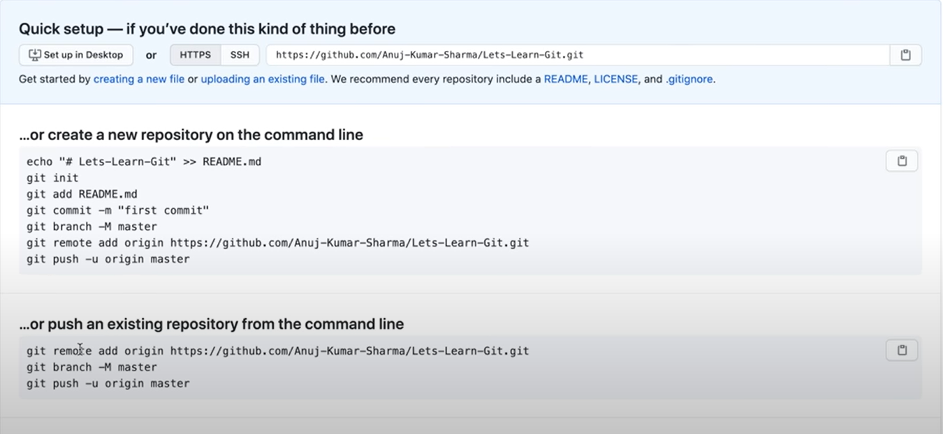git push -u origin master

**git remote** -v : check whether your local git is connected with any remote github account or not

**git push** : used to push a code to github

**git pull** : used to pull code into our local pc from github

**git clone <repo url> : used to clone any repository from github**

